1. How do you distinguish between shutil.copy() and shutil.copytree()?

**Answer :**

shutil.copy() will copy only a single file.

shutil.copytree() will copy the entire folder along with its contents.

2. What function is used to rename files??

**Answer :**

shutil.move() is the function that is used for renaming as well as moving the files.

3. What is the difference between the delete functions in the send2trash and shutil modules?

**Answer :**

send2trash function will move a file or folder to recycle bin, while shutil modules will permanently delete the files or folders.

4.ZipFile objects have a close() method just like File objects’ close() method. What ZipFile method is

equivalent to File objects’ open() method?

**Answer :**

The zipfile.ZipFile() function is equivalent to the open() function; the first argument is the filename, and the second argument is the mode to open the ZIP file in (read, write, or append).

5. Create a programme that searches a folder tree for files with a certain file extension (such as .pdf

or .jpg). Copy these files from whatever location they are in to a new folder.

**Answer :**

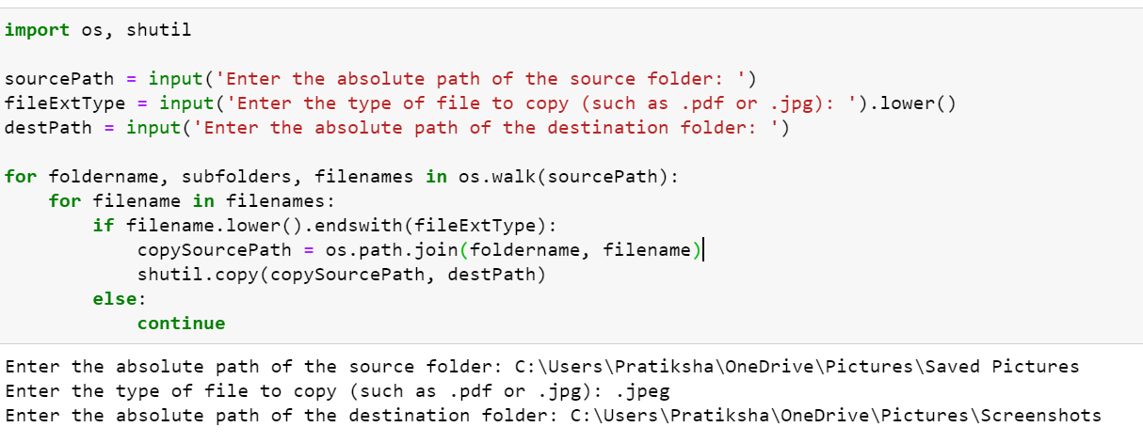

This will copy the files/images from one destination to another.